# **Azure Synapse vs Azure Data Factory vs Azure Databricks:**

## 1. Azure Synapse Analytics

### **Definition**

Azure Synapse Analytics is a **data integration, big data, and enterprise data warehouse (EDW) solution**. It allows organizations to query, analyze, and visualize massive amounts of structured and semi-structured data at scale.

It combines **SQL-based querying, on-demand serverless analytics, dedicated SQL pools (data warehouse), and integration with Power BI** for visualization.

### **Core Capabilities**

* **Data Warehousing**: Dedicated SQL pools allow storage of petabytes of relational data for fast query performance.
* **Serverless Queries**: Analyze raw data from Azure Data Lake without pre-loading it into tables.
* **Integration**: Tight integration with Power BI and Azure Machine Learning.
* 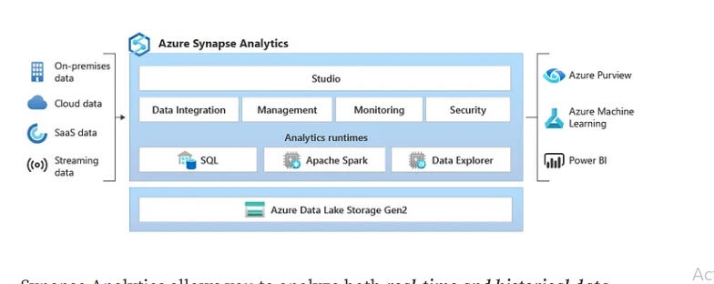**Hybrid ETL/ELT**: Can transform data directly within the warehouse.

## 2. Azure Data Factory (ADF)

### **Definition**

Azure Data Factory is a **cloud-based ETL (Extract, Transform, Load) and ELT (Extract, Load, Transform) service** that allows organizations to create, schedule, and orchestrate **data pipelines**.

It is often referred to as the **“glue”** that moves data between services.

### **Core Capabilities**

* **Data Integration**: Connects to 90+ on-premises and cloud data sources (databases, SaaS apps, flat files).
* **Data Movement**: Transfers data from source to destination.
* **Data Transformation**: Uses **Mapping Data Flows** or external compute engines like Databricks to transform data.
* **Scheduling and Orchestration**: Create pipelines with triggers, dependencies, and monitoring.
* **Hybrid Support**: Connects with on-premises data via self-hosted integration runtime.

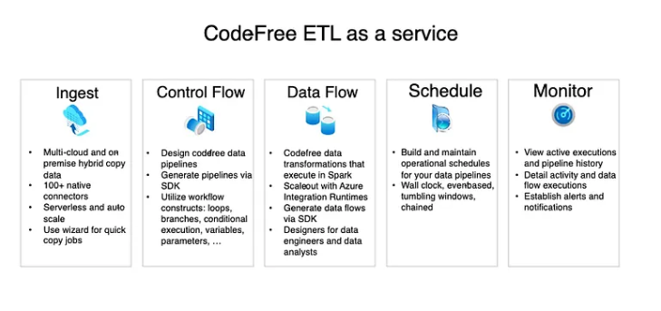

## 3. Azure Databricks

### **Definition**

Azure Databricks is a **data engineering, data science, and machine learning platform** built on **Apache Spark**. It provides a collaborative environment for **big data processing, AI, and advanced analytics**.

While Synapse focuses on analytics and ADF focuses on orchestration, **Databricks specializes in large-scale data transformation, AI/ML model development, and real-time streaming analytics**.

### **Core Capabilities**

* **Big Data Processing**: Can process terabytes to petabytes of structured, semi-structured, and unstructured data.
* **Machine Learning**: Built-in MLflow for managing ML experiments and models.
* **Real-Time Analytics**: Supports real-time event processing from IoT devices or Kafka streams.
* **Data Engineering**: Prepares raw data for analytics and AI workloads.
* **Collaboration**: Provides notebooks (Python, R, SQL, Scala) for developers, analysts, and data scientists.

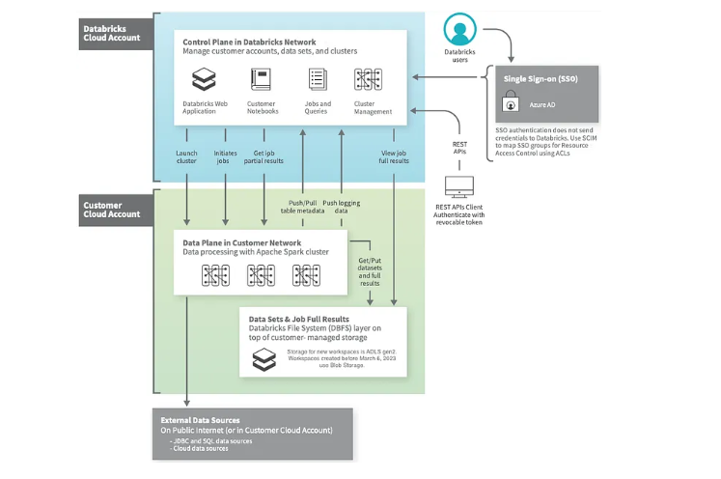

## 4. Comparative Analysis

Now, let’s break down how these three services compare across multiple dimensions:

| **Feature/Aspect** | **Azure Synapse Analytics** | **Azure Data Factory (ADF)** | **Azure Databricks** |
| --- | --- | --- | --- |
| **Purpose** | Data warehousing & analytics | Data integration & orchestration | Data engineering & AI/ML |
| **Best For** | BI dashboards, reporting, SQL-based queries | ETL/ELT workflows, data ingestion | Big data processing, AI, ML, streaming |
| **Data Handling** | Structured & semi-structured | Any (structured, semi, unstructured) | Any (structured, semi, unstructured, unformatted) |
| **Compute Engine** | SQL-based | Managed pipelines | Apache Spark |
| **Integration** | Power BI, ADF, ML | Synapse, Databricks, SQL, APIs | Synapse, ADF, ML, Data Lake |
| **Users** | Data analysts, BI developers | Data engineers, integration specialists | Data scientists, ML engineers, data engineers |
| **Real-Time Support** | Limited (mostly batch) | Limited (trigger-based) | Strong (streaming & AI) |
| **Pricing** | Pay per TB (serverless) or provisioned DWU (dedicated) | Pay per pipeline activity run | Pay per cluster compute & storage |
| **Example Use Case** | Retail sales reporting | Banking ETL pipelines | Healthcare AI models & IoT |

## 5. How They Work Together

In practice, many enterprises use **all three services together** to create a unified data platform.

### **End-to-End Workflow Example: E-commerce Company**

1. **Data Ingestion (ADF)**
   * Pulls customer orders, website logs, and payment data from multiple sources (SQL DB, APIs, CSVs).
2. **Data Transformation (Databricks)**
   * Cleans raw clickstream logs, applies ML models to predict customer churn, and enriches datasets.
3. **Data Storage & Analytics (Synapse)**
   * Loads final curated datasets into a data warehouse.
   * Business analysts run SQL queries and visualize dashboards in Power BI.

This combination ensures **data flows seamlessly** from raw sources to insights, supporting real-time analytics and AI.

## 6. Real-Time Industry Use Cases

### **a) Finance**

* **ADF**: Automates ingestion of stock market data.
* **Databricks**: Runs real-time fraud detection models.
* **Synapse**: Stores transaction history for compliance reporting.

### **b) Retail**

* **ADF**: Extracts data from ERP, CRM, and e-commerce platforms.
* **Databricks**: Processes clickstream and recommendation engine models.
* **Synapse**: Provides dashboards for sales forecasting and inventory optimization.

### **c) Healthcare**

* **ADF**: Collects patient records from hospital systems.
* **Databricks**: Runs ML models to detect anomalies in patient vitals.
* **Synapse**: Supports regulatory reporting and research dashboards.

## 7. Choosing the Right Tool

Guideline for **decision-making**:

* Use **Azure Synapse** when you want:
  + Business Intelligence, dashboards, and SQL-based analytics.
  + To centralize enterprise reporting.
* Use **Azure Data Factory** when you want:
  + To orchestrate ETL/ELT pipelines.
  + Move and schedule data flows between systems.
* Use **Azure Databricks** when you want:
  + Large-scale data processing, data science, and AI/ML.
  + Real-time streaming analytics.

## 8. Conclusion

Azure Synapse Analytics, Azure Data Factory, and Azure Databricks are **not competitors but complementary services** in the Azure ecosystem.

* **Azure Synapse** is your **data warehouse and analytics layer**.
* **Azure Data Factory** is your **pipeline orchestration and integration engine**.
* **Azure Databricks** is your **data science, AI, and big data transformation platform**.

When combined, they enable enterprises to build a **modern cloud data platform** that supports everything from **raw data ingestion to predictive AI models and business dashboards**.

In essence, the choice isn’t about **which one to use**, but **when to use each**, depending on your workload.